**PRACTICAL 7**

**Aim:**Implementation and analysis of Linear regression through graphical methods.

**Linear Regression:**

a. Regression analysis is a very widely used statistical tool to establish a relationship model between two variables.

b. One of these variables is called predictor variable whose value is gathered through experiments. The other variable is called response variable whose value is derived from the predictor variable.

c. In Linear Regression these two variables are related through an equation, where exponent (power) of both these variables is 1.

d. Mathematically a linear relationship represents a straight line when plotted as a graph.

e. A non-linear relationship where the exponent of any variable is not equal to 1 creates a curve.

f. The general mathematical equation for a linear regression is y = ax + b

Following is the description of the parameters used −

y is the response variable.

x is the predictor variable.

a and b are constants which are called the coefficients.

g. Steps to Establish a Regression: A simple example of regression is predicting weight of a person when his height is known. To do this we need to have the relationship between height and weight of a person.

The steps to create the relationship is −

a) Carry out the experiment of gathering a sample of observed values of height and corresponding weight.

b) Create a relationship model using the lm() functions in R.

c) Find the coefficients from the model created and create the mathematical equation using these

d) Get a summary of the relationship model to know the average error in prediction. Also called residuals.

e) To predict the weight of new persons, use the predict() function in R

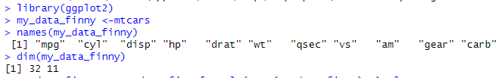

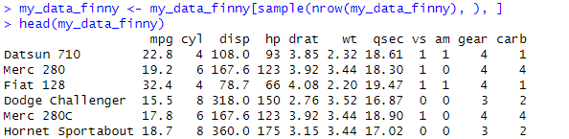

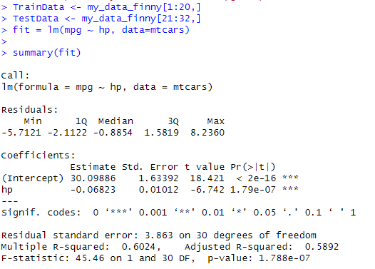

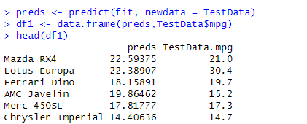





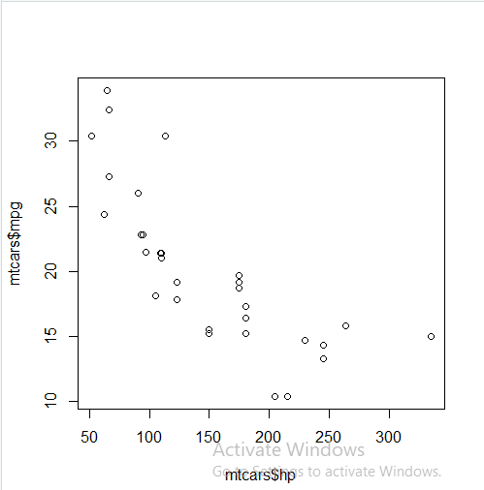

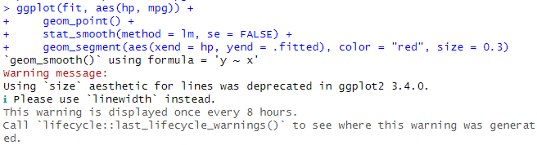

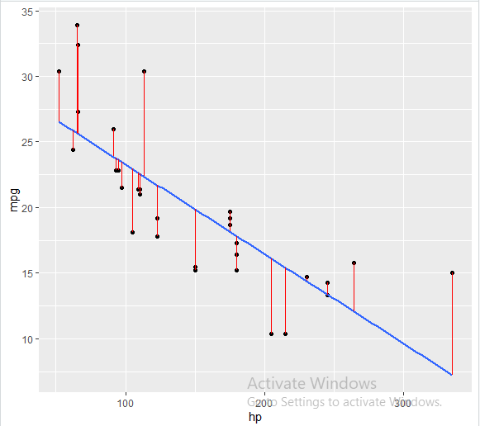

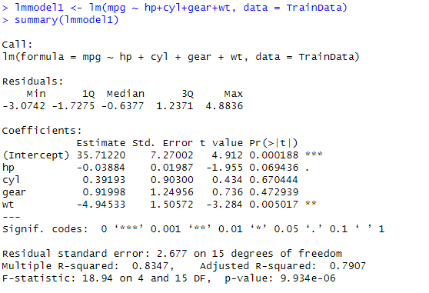

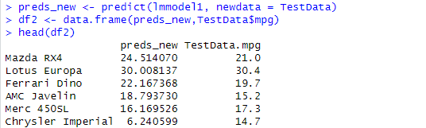



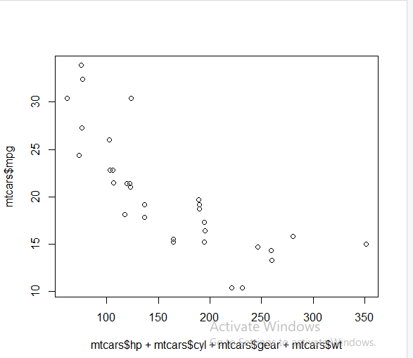

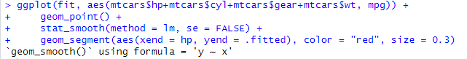

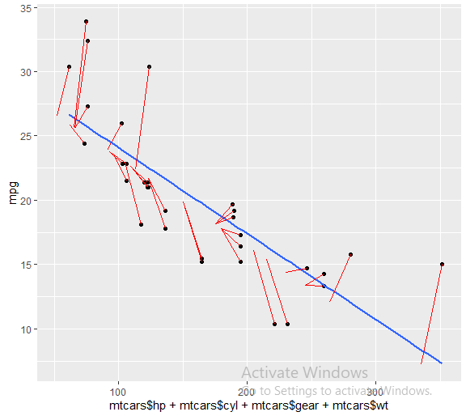

**Conclusion:** Successfully implemented and analyzed Linear regression through graphical methods.